CHAPTER I
THE PROBLEM AND ITS BACKGROUND
This chapter covers the introduction, study background, problem statement and research questions, aims, scope and delimitations, theoretical and conceptual frameworks, study significance, and operational definitions of words.
A. Introduction
In today’s fast-paced healthcare environment, pharmacies play a vital role in ensuring the availability and safety of medicines for patients. Traditional inventory management methods, which often rely on manual recording and monitoring, are prone to human error, inefficiency, and data inaccuracy. These challenges can lead to issues such as stock shortages, overstocking, and the dispensing of expired medications, all of which may compromise patient safety and business operations.
With the advancement of web technologies, automated systems have become essential tools in improving operational efficiency. A Web-Based Pharmacy Inventory Management System with Stock Monitoring and Expiry Tracking is designed to address these challenges by providing a centralized, real-time platform for managing pharmaceutical inventory. This system enables pharmacy staff to easily track stock levels, monitor expiration dates, and generate reports for better decision-making.
The proposed system aims to enhance accuracy, reduce manual workload, and improve overall pharmacy management. By integrating stock monitoring and expiry tracking features, it ensures that medicines are always available, properly managed, and safe for consumption. Ultimately, this system supports better healthcare service delivery and promotes patient safety.
B. Background of the Study
Technology plays a pivotal role in optimizing business operations, particularly within the healthcare and pharmaceutical sectors. Pharmacies handle a vast array of pharmaceutical products daily, requiring meticulous monitoring of stock levels, strict tracking of expiration dates, and accurate recording of transactions. Despite these demands, many small and medium-sized pharmacies still rely on manual recording methods, such as paper-based ledgers and basic spreadsheets. These traditional approaches are inherently time-consuming, prone to human error, and frequently result in inaccurate inventory counts, undetected expired products, and delayed restocking cycles.

Inventory management is a critical pillar of pharmacy operations, as it ensures that essential medicines remain consistently available to patients while actively preventing the retention and dispensing of expired goods. Failing to monitor expiration dates effectively can lead to severe financial losses, inventory wastage, and critical health risks for consumers. Consequently, there is an urgent need for a reliable, automated solution that empowers pharmacy personnel to manage their inventory efficiently and securely.

The proposed Web-Based Pharmacy Inventory Management System with Stock Monitoring and Expiry Tracking is designed to streamline and automate these essential inventory workflows. The system records stock levels in real-time, monitors quantities, generates automated low-stock alerts, and tracks expiration timelines. Developed as a web-based platform, it enables authorized users to securely access the system across computers connected via a local network or the internet.

Ultimately, this study aims to enhance the overall efficiency, data accuracy, and security of pharmacy inventory management. Through automation, pharmacy staff can significantly reduce manual administrative burdens, minimize operational errors, and deliver safer, more reliable services to the community.

C. Statement of the Problem
Effective inventory management is critical to maintaining the availability, safety, and quality of pharmaceutical products. However, many small and medium-sized pharmacies continue to utilize manual inventory practices, such as handwritten logs and unintegrated spreadsheets, to monitor stock levels and expiration dates. These legacy methods are susceptible to human error, data discrepancies, delayed replenishment, and oversight regarding expiring goods.

These inefficiencies expose pharmacies to significant risks, including stockouts, overstocking, financial leakage, and the accidental dispensing of expired medications—all of which jeopardize patient safety and degrade operational performance. Furthermore,
while various enterprise inventory systems exist, many are cost-prohibitive, overly complex, or lack the specific integrated stock-monitoring and expiry-tracking features required by small and medium-scale retail pharmacies.

To address these gaps, this study aims to develop a Web-Based Pharmacy Inventory Management System with Stock Monitoring and Expiry Tracking that automates inventory workflows, boosts record accuracy, assists staff in tracking product lifecycles, and facilitates data-driven decision-making through timely reporting and alert mechanisms.
The study sought to answer the following questions:
1. How can a web-based pharmacy inventory management system improve the monitoring and overall management of medicine inventory?
2. How can the system assist pharmacy staff in effectively tracking medicine expiration dates?
3. How can the system provide timely and reliable notifications for low-stock thresholds and expiring medicines?
4. How can the system enhance the accuracy, security, and reliability of pharmacy inventory records compared to manual methods?
5. How can the system support pharmacy management in making informed inventory and operational decisions?
- Objectives of the Study
To design, develop, and evaluate a Web-Based Pharmacy Management System that automates product tracking, purchase and sales management, stock monitoring, and expiry tracking to enhance operational efficiency and accuracy for community pharmacies.

Specific Objectives:
1. To design and develop a web-based application featuring integrated modules for Dashboard, Products, Purchases, Sales, Suppliers, Categories, User Management, and Reports.
2. To automate product inventory updates based on purchasing and sales transaction processing.
3. To implement stock monitoring and automated notification alerts for low-stock quantities and critical expiration dates.
4. To generate comprehensive reports on sales, inventory status, purchase histories, and expiring products to support management decision-making.
5. To evaluate the usability of the system’s performance and technical quality using the ISO 25010 software quality standards in terms of functional suitability, reliability, usability, performance efficiency, and security.

- Scope and Delimitation
This study focuses on the design and development of a web-based inventory management system tailored specifically for small and medium-sized pharmacies. The core system features include:
a. User authentication and role-based access control (Admin and Staff)
b. Comprehensive medicine inventory management (CRUD operations)
c. Real-time stock monitoring and level updates
d. Expiry date tracking and shelf-life management
e. Automated low-stock and near-expiry alerts/notifications
f. Comprehensive inventory report generation and exporting
g. An administrative dashboard for monitoring overarching inventory status
- The application is engineered to be accessed via standard desktop or laptop computers utilizing a local area network (LAN) or internet connection.

Limitations:
The boundaries of the study are defined by the following constraints:
a. The system's functional scope is strictly limited to inventory management and does not encompass point-of-sale (POS) cash register operations or financial accounting modules.
b. Online payment processing, customer-facing e-commerce shopping carts, and online ordering features are excluded.
c. System uptime and real-time syncing remain dependent on stable internet or local network connectivity.
d. Barcode scanning capabilities are excluded from the baseline implementation unless compatible external hardware is independently integrated by the user.
e. System access is strictly restricted to authorized administrative and pharmacy staff accounts.

- Theoretical Framework
The study is anchored on the following theories and concepts that support the development of the proposed system:
- Inventory Management Theory explains the importance of controlling and monitoring stocks to maintain the right balance between supply and demand. In a pharmacy setting, proper inventory management ensures that medicines are available when needed while minimizing losses caused by expired or excess stocks. The system applied this theory by:
- Monitoring medicine quantities in real time
- Tracking stock movement
- Providing alerts for low stock and expired medicines
- Organizing medicine records systematically
This theory supports the system’s goal of improving inventory accuracy and operational efficiency.
- Information System Theory states that technology and computerized systems help organizations collect, process, store, and manage information efficiently. A web-based information system improves decision-making by providing accurate and timely data. The proposed Pharmacy Inventory Management System uses this theory by:
- Automating inventory processes
- Storing medicine information digitally
- Generating reports instantly
- Reducing manual errors in recording data
- This theory supports the use of technology in improving pharmacy management operations. The Technology Acceptance Model (TAM) developed by Fred Davis explains that users are more likely to accept and use a system if they find it useful and easy to use. The proposed system follows this model through:
- User-friendly interface design
- Easy navigation and accessibility
- Fast monitoring and reporting features
- Simplified inventory management process
This theory supports the acceptance and usability of the system among pharmacy staff and administrators.

- Conceptual Framework
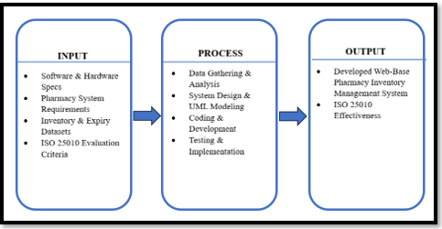
The study follows the Input-Process-Output (IPO) Model as the conceptual framework of the system.
Figure 1: The Input-Process-Output Model
- Input
The inputs of the study include:
- Software & Hardware Specs
- Pharmacy System Requirements
- Inventory & Expiry Datasets
- ISO 25010 Evaluation Criteria
- Process
The system processes the data through:
- Data Gathering & Analysis
- System Design & UML Modeling
- Coding & Development
- Testing & Implementation
- Output
The expected outputs of the study are:
- Developed Web-Base Pharmacy Inventory Management System
- ISO 25010 Effectiveness

- Significance of the Study
The findings and implementation of this study will provide substantial benefits to the following stakeholders:
Pharmacy Owners: The system will enable accurate inventory oversight, minimize financial losses caused by expired or wasted stock, and optimize overall business productivity.
Pharmacy Staff: By automating repetitive manual data-entry and tracking tasks, the system will streamline daily workflows, allowing personnel to focus more on customer service and operational efficiency.
Customers: Patients and consumers will experience safer, more reliable healthcare services through guaranteed medicine availability and minimized risks of purchasing compromised products.
Future Researchers: This study can serve as a comprehensive reference and foundation for future academic inquiries related to pharmacy automation, inventory management systems, and healthcare web technologies.
The Researchers: Undertaking this project will deepen the proponents' practical competencies in web application development, database architecture, systems analysis, and software engineering.

- Operational Definition of Terms
The following terms are defined for better understanding of the study:
Inventory Management System – A computerized system used to organize, monitor, and control the storage and movement of medicines and pharmacy products.
Stock Monitoring – The process of tracking the quantity and availability of medicines to avoid shortages or overstocking.
Expiry Tracking – A feature that monitors the expiration dates of medicines to prevent the use or sale of expired products.
Web-Based System – A system that operates through a web browser and can be accessed using the internet or a local network.
Database – An organized collection of related data used for storing medicine records, transactions, and user information.
Administrator – The authorized user responsible for managing the system, users, reports, and overall operations.
Pharmacist – A licensed professional or system user who manages medicine inventory, stock updates, and expiry monitoring.
Medicine Inventory – The complete list and record of medicines available in the pharmacy, including quantity, price, and expiration date.
Report Generation – The process of creating inventory reports, stock summaries, and expiry reports from the system data.
User Authentication – A security process that verifies the username and password of users before allowing access to the system.

CHAPTER II

REVIEW OF RELATED LITERATURE AND STUDIES
This chapter presented the related literature and studies relevant to the development of the Web-Based Pharmacy Inventory Management System. It included information gathered from books, journals, websites, and previous studies that provided ideas and concepts related to inventory management systems, stock monitoring, expiry tracking, and web-based technologies. The purpose of this chapter is to support the study by showing existing systems, techniques, and research that are related to the proposed system and help the researchers improve its design and functionality.
- Foreign Literature
Global literature regarding pharmaceutical standards frequently addresses the critical intersection of technology and public health safety. Regulatory bodies, such as the U.S. Food and Drug Administration (2026), provide extensive documentation emphasizing the necessity of rigorous drug storage and expiration monitoring to ensure that medications remain potent and safe for consumer use. This literature highlights that without systematic tracking, the risk of sub-therapeutic treatment or toxic reactions increases significantly, making automated alerts a fundamental requirement for modern dispensaries. Furthermore, global supply chain literature suggests that modern best practices involve utilizing real-time data analytics to forecast demand, thereby preventing the "bullwhip effect" in pharmaceutical supply chains where minor changes in consumer demand cause large, destabilizing fluctuations in inventory levels.

Additional foreign literature explores theoretical models of technology adoption, such as the Technology Acceptance Model (TAM), to evaluate system integration in medical environments. Recent studies emphasize that the successful deployment of digital healthcare platforms relies significantly on end-users' evaluations of perceived usefulness and perceived ease of use (Nazari-Shirkouhi et al., 2023). This theoretical perspective is vital in the development of pharmacy systems, as it dictates that complex features—such as batch tracking and real-time stock alerts—must be integrated within intuitive interfaces to guarantee high adoption rates among healthcare personnel (Alajmi et al., 2023). Collectively, these contemporary foreign frameworks advocate for a design philosophy that bridges advanced technical functionality with user-centric accessibility to secure long-term system viability.

- Foreign Studies
Internationally, the transition from manual pharmaceutical tracking to automated digital frameworks has been a core focus of health informatics research. According to Laudon and Laudon (2021), the integration of sophisticated management information systems is critical for modern enterprises to minimize operational friction and maximize data-driven productivity. In global pharmacy operations, international studies have consistently shown that digital platforms significantly reduce the incidence of human error associated with handwritten logs and spreadsheets, which frequently lead to stock discrepancies and the inadvertent storage of expired medical supplies.

Moreover, systematic reviews in health informatics highlight the transformative impact of digital technologies on pharmacy efficiency and patient safety. Research from institutions such as the National Center for Biotechnology Information (2025) notes that modern inventory systems function as essential safety barriers that prevent the dispensing of compromised or outdated pharmaceuticals. By utilizing real-time monitoring and automated data processing, international healthcare facilities have demonstrated marked improvements in both regulatory compliance and financial stability. These foreign investigations serve as a strong benchmark, proving that automation is a global necessity for maintaining the integrity of the medical supply chain.

- Local Literature
Within the Philippines, the regulatory framework established by the Food and Drug Administration (FDA) serves as the primary governing literature for pharmacy operations. The Philippine Food and Drug Administration (2024) has published updated guidelines that emphasize the need for meticulous registration, storage, and tracking of pharmaceutical products to protect the Filipino public from counterfeit, substandard, or expired medicines. This local literature highlights that pharmacy owners are legally and ethically obligated to maintain accurate records of their inventory's origin, batch numbers, and expiration dates. These stringent mandates reinforce the necessity for automated systems capable of generating compliance-ready records and maintaining an audit trail for regulatory inspections.

Furthermore, professional literature concerning Information Technology education in the Philippines discusses the role of capstone projects in addressing real-world community needs. Scholarly articles often point out that the development of localized web-based systems directly contributes to national digital transformation initiatives by modernizing the operations of small-scale essential services. This literature supports the premise that academic innovations in inventory management provide a dual benefit: enhancing the technical competencies of student-researchers while delivering tangible, cost-effective solutions to the operational hurdles faced by Filipino SMEs.

- Local Studies
In the Philippine setting, the modernization of pharmacy inventory practices is a burgeoning area of academic interest, particularly for small to medium-sized enterprises. Local academic studies have observed that many community pharmacies still grapple with the inefficiencies of legacy systems, such as manual spreadsheets or paper-based ledgers, which are highly susceptible to data loss, physical damage, and recording inaccuracies. Research conducted within the country suggests that the lack of automated tracking often leads to severe financial losses for local drugstores due to expired stock that was overlooked during manual audits.

Furthermore, local assessments of technology adoption in the healthcare sector indicate a positive correlation between automated inventory management and improved customer service delivery. Philippine-based studies frequently highlight that when pharmacy staff are relieved of tedious manual stock-counting tasks, they can dedicate more time to professional patient consultations, prescription verification, and quality customer care. These local findings emphasize the importance of creating systems that are not only functionally robust but also culturally and operationally tailored to the Philippine retail pharmacy environment, bridging the gap between traditional practices and modern healthcare standards.

- Synthesis
The reviewed foreign and local literature and studies collectively confirm that the shift from manual to automated pharmacy inventory management is both a global and local imperative driven by patient safety, regulatory compliance, and operational efficiency. Foreign sources provide a broad theoretical and technical foundation, emphasizing that automation is key to minimizing human error and securing the medical supply chain. Meanwhile, local sources contextualize these requirements within the Philippine regulatory environment, highlighting the specific logistical hurdles faced by community pharmacies.

The Research Gap: Despite the proliferation of commercial software and basic inventory templates, a distinct gap remains in the market. Many available platforms are either generic spreadsheets prone to error, expensive enterprise systems tailored exclusively for large hospital networks, or complex point-of-sale applications that lack focused inventory features. There remains a lack of accessible, lightweight, web-based solutions specifically designed to combine real-time stock monitoring, automated low-stock alerts, and batch expiry tracking tailored for small and medium-sized Philippine pharmacies.

The proposed Web-Based Pharmacy Inventory Management System with Stock Monitoring and Expiry Tracking directly addresses this gap by delivering an integrated, user-friendly, and cost-effective digital tool designed to modernize local pharmacy operations while aligning with both international standards and local regulatory demands.

CHAPTER III

METHODOLOGY
This chapter presented the research methodology used in the development of the Web-Based Pharmacy Inventory Management System. It discussed the research design, system development process, respondents of the study, data gathering procedures, software and hardware requirements, and testing methods used to ensure the effectiveness and reliability of the system. The chapter also explained how the researchers designed, developed, and evaluated the system to help pharmacies manage medicine inventory, monitor stock levels, and track product expiration dates efficiently.
A. Research Design
This study utilized a Descriptive-Developmental Research Design. This dual-phased approach is structured to systematically investigate existing operational conditions and subsequently engineer an applied technical solution to address identified gaps.
- Descriptive Phase: This phase focused on examining, documenting, and analyzing the current operational workflows, manual inventory pain points, and reporting requirements inherent in small-to-medium pharmacy operations. Through systematic data gathering, this phase identified the operational inefficiencies, risks of expired stock accumulation, and communication bottlenecks associated with traditional paper-based ledgers and unintegrated spreadsheets.
- Developmental Phase: Guided by the insights gathered during the descriptive phase, this phase focused on the practical application of software engineering principles. It encompassed the design, coding, testing, and refinement of the web-based inventory management system utilizing the Agile development framework, ensuring iterative feedback loops and continuous system optimization.
Suitability of the Descriptive-Developmental Approach:
The descriptive-developmental approach is highly suitable for this capstone project because the research objective extends beyond mere theoretical inquiry into tangible software artifact creation:
- Evidence-Based Design: The descriptive component ensures that the system features are not arbitrarily created, but are directly rooted in the real-world operational challenges and requirements of pharmacy staff and owners.
- Iterative Problem Solving: The developmental component allows the researchers to iteratively build, test, and improve the software solution, ensuring that technical capabilities (such as automated expiry tracking and low-stock alerts) directly resolve the problems documented in the descriptive phase.

B. Data Collection
To gather comprehensive and accurate information for both the descriptive analysis and system evaluation phases, data was collected using three primary methods:
- Interviews: Semi-structured interviews were conducted with pharmacy personnel, administrators, and owners. These sessions aimed to establish core functional requirements, such as essential product details, optimal low-stock threshold parameters, batch management practices, and specific reporting needs required for daily pharmacy operations.
- Direct Observation: The researchers conducted direct observations of pharmacy workflows, specifically observing staff during stock-in activities, inventory audits, and shelf-expiry checking. This method allowed the development team to accurately model data flows, map out user role requirements, and understand the physical constraints of pharmacy environments.
- Questionnaires: Structured questionnaires—administered during the system evaluation phase—utilized standardized instruments based on the ISO 25010 software quality model. These questionnaires were distributed to end-users (pharmacy staff and owners) and Information Technology (IT) experts to systematically measure system usability, functional suitability, performance efficiency, and security.

C. System Development Life Cycle
This study adopted the Agile Model as the Software Development Life Cycle (SDLC) in developing the proposed Web-Based Pharmacy Inventory Management System. Agile is an iterative and flexible software development methodology that emphasizes continuous planning, development, testing, and improvement. This approach enabled the researchers to divide the project into manageable development cycles (sprints), allowing the system to be continuously improved based on testing results and user feedback.
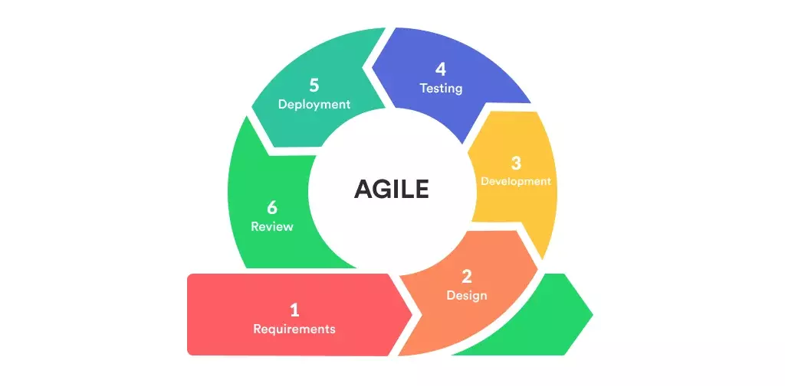
The Agile Model was selected because it is well-suited for developing web-based applications that require continuous enhancement. It allowed the researchers to gradually implement and improve core modules such as the dashboard, product management, purchase management, sales management, supplier management, category management, user management, stock monitoring, notifications, and report generation.

Figure 2: SLDC Agile Model

Agile Development Process:
The Agile development process followed these phases:
- Planning
- System Design
- Development
- Testing
- Deployment
- Review and Maintenance
These phases were repeated until the system met the functional requirements and quality standards established for the study.

Planning Phase
During this phase, the researchers gathered system requirements through interviews, observations, and consultations with pharmacy personnel. Based on the collected information, the researchers identified the major features of the system, including:
- Dashboard
- Product Management
- Purchase Management
- Sales Management
- Supplier Management
- Category Management
- User Management
- Stock Monitoring
- Low-Stock Notifications
- Reports
- User Authentication

System Design Phase
In this phase, the researchers designed the database structure, user interface, navigation flow, and overall system architecture. The design focused on creating a responsive, organized, and user-friendly web application that would simplify pharmacy operations while ensuring efficient data management.

Development Phase
The system was developed using modern web development technologies and the Laravel framework. The researchers utilized:
- Laravel Framework
- PHP
- MySQL
- Blade Templating Engine
- Bootstrap
- HTML
- CSS
- JavaScript
- Laravel Mix
- Composer
Development was performed incrementally, with each module being implemented, tested, and improved throughout the Agile development cycle.

Testing Phase
After each development iteration, the system underwent testing to verify that every module functioned correctly. The researchers conducted:
- Functionality Testing
- Usability Testing
- Error Detection and Debugging
- System Validation
This phase ensured that the developed features met the requirements of pharmacy users.

Deployment Phase
Upon successful testing, the completed system was deployed in a local web server environment using XAMPP. The application became accessible through a web browser, allowing authorized users to perform inventory management and other pharmacy-related operations.

Review and Maintenance Phase
Following deployment, the researchers continuously monitored the system and collected user feedback to improve its performance, fix identified issues, and implement additional enhancements whenever necessary.
A. Database Design
Database design is the process of organizing and structuring data to ensure efficient storage, retrieval, and management of information. The proposed system uses MySQL as its database management system, while Laravel's Eloquent ORM manages communication between the application and the database.
The database stores information related to users, products, suppliers, purchases, sales, categories, inventory records, notifications, reports, and system settings. Proper database design ensures data integrity, minimizes redundancy, and supports efficient processing of pharmacy transactions.
1. Context Diagram
A Context Diagram presents the proposed Pharmacy Inventory Management System as a single process and illustrates its interaction with external users. It identifies the flow of information between the system and its users without showing internal processes.
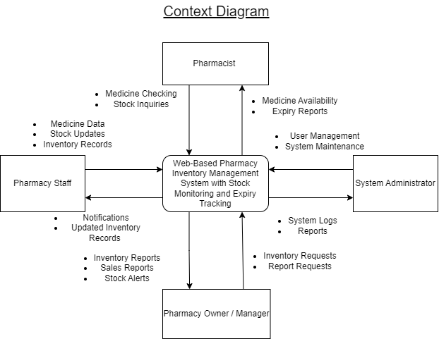

Figure 3: Context Diagram
System Administrator
● Manages user accounts
● Assigns roles and permissions
● Configures system settings
● Maintains the database
● Generates reports
● Monitors overall system performance
Pharmacy Staff
● Adds and updates product information
● Records purchases and sales
● Monitors stock levels
● Tracks medicine expiration dates
● Receives stock notifications
Pharmacist
● Reviews medicine availability
● Monitors inventory
● Checks expiry dates
● Reviews inventory records
● Receives low-stock alerts
Pharmacy Manager
● Reviews reports
● Monitors inventory performance
● Analyzes sales and purchases
● Uses reports for business decision-making

- Data Flow Diagram
A Data Flow Diagram (DFD) illustrates how information flows within the Pharmacy Inventory Management System. It shows how users interact with the system, how data is processed, and how information is stored in the database

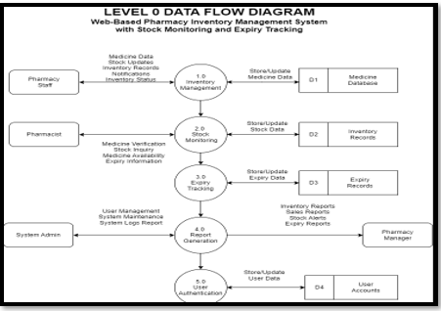

Figure 4: Data Flow Diagram
- Product Management – Adds, updates, and removes product records.
- Purchase Management – Records incoming purchases and updates inventory quantities.
- Sales Management – Processes sales transactions and automatically deducts product stock.
- Stock Monitoring – Monitors inventory levels and identifies low-stock products.
- Expiry Tracking – Detects expired and near-expiry medicines.
- Supplier Management – Maintains supplier information and purchase records.
- Report Generation – Produces inventory, sales, purchase, and stock reports.
- User Authentication – Verifies user credentials before granting access to the system.
- Entity Relationship Diagram
An Entity Relationship Diagram (ERD) illustrates the database structure of the proposed system by showing the relationships among the major database tables.
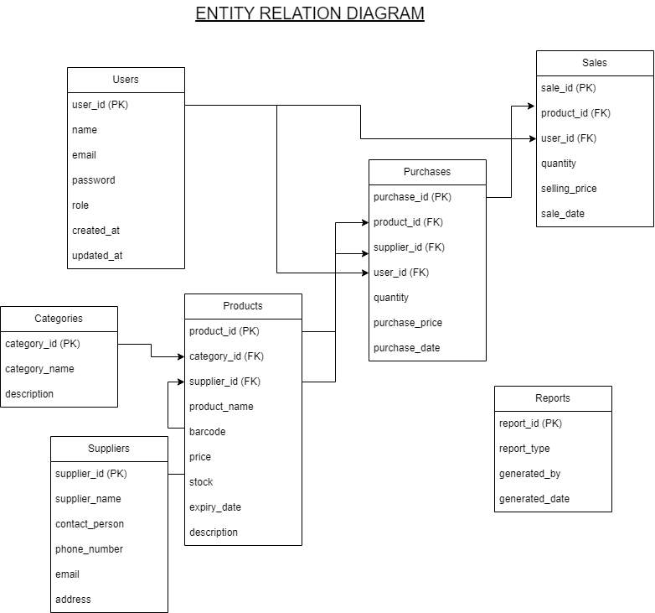

Figure 5: Entity Relationship Diagram
- Users (Primary Key: user_id) – Stores user account information, login credentials, and assigned roles.
- Products (Primary Key: product_id) – Stores medicine details, prices, stock quantities, and expiration dates.
- Categories (Primary Key: category_id) – Organizes medicines into categories.
- Suppliers (Primary Key: supplier_id) – Stores supplier information
- Purchases (Primary Key: purchase_id) – Records purchased products and supplier transactions.
- Sales (Primary Key: sale_id) – Stores pharmacy sales transactions.
- Inventory (Primary Key: inventory_id) – Tracks stock movement and inventory updates.
- Reports (Primary Key: report_id) – Stores generated reports for inventory monitoring and business analysis.
- Use Case Diagram
A Use Case Diagram illustrates the interactions between users and the Pharmacy Inventory Management System. It defines the functions that each user can perform according to their assigned role.
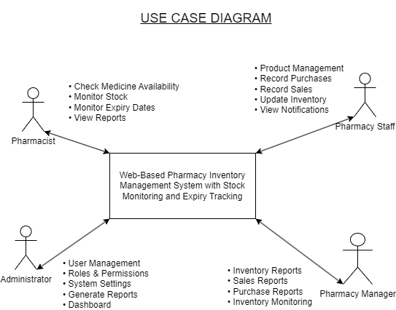

Figure 6: Use Case Diagram
System Administrator
● Manage users
● Assign roles and permissions
● Manage products
● Manage suppliers
● Manage categories
● Monitor inventory
● Generate reports
● Configure system settings
Pharmacy Staff
● Add and update products
● Record purchases
● Record sales
● Update inventory
● Monitor expiry dates
● View notifications
Pharmacist
● Check medicine availability
● Review inventory records
● Monitor stock levels
● Monitor expired medicines
● View notification alerts
Pharmacy Manager
● View reports
● Monitor inventory status
● Review sales and purchase reports
● Support inventory planning and decision-making
Development Tool | Purpose
Laravel Framework | Primary PHP framework used for developing the web application, handling routing, authentication, controllers, models, middleware, and database operations.
PHP | Server-side programming language used to implement the system's business logic.
MySQL | Database management system used to store products, users, purchases, sales, suppliers, categories, inventory records, and reports.
Blade Templating Engine | Laravel's template engine used to create dynamic web pages and reusable layouts.
Bootstrap | Front-end framework used to create a responsive and user-friendly interface.
HTML | Defines the structure and content of web pages.
CSS | Styles and formats the user interface.
JavaScript | Adds interactive features and enhances user experience.
Laravel Mix | Compiles and manages front-end assets such as CSS and JavaScript files.
Composer | Dependency manager used to install and maintain Laravel packages and project libraries.
XAMPP | Provides the local server environment for development and testing.
Visual Studio Code | Source code editor used throughout the development process.
- Development Tools
The researchers used the following technologies in developing the system:
Table 1: Development Tools and Purposes Table
F. Evaluation Procedure
The system is evaluated using ISO 25010 that provides a standard for assessing the system’s quality based on the following criteria:

Functional Suitability
Functional Suitability refers to the ability of the system to provide the necessary features and functions required to manage medicine inventory, monitor stock levels, track medicine expiration dates, generate reports, and manage users accurately and completely.

Reliability
Reliability refers to the ability of the system to consistently perform its intended functions without failures while maintaining accurate inventory records and stable operation.

Usability
Usability refers to the ease with which pharmacy staff, pharmacists, administrators, and managers can learn, understand, and efficiently use the system.

Performance Efficiency
Performance Efficiency refers to the ability of the system to process inventory transactions, retrieve records, and generate reports quickly while efficiently utilizing available system resources.

Security
Security refers to the capability of the system to protect user accounts, inventory records, and confidential information through user authentication, controlled access, and secure data management.
G. Evaluation Tool

The primary research instrument for this study is an evaluation questionnaire using the ISO 25010 software quality standards.
Shown below is the ISO 25010 evaluation form:
Legend: 4- Strongly Agree 3 – Agree 2 – Disagree 1 – Strongly Disagree
CRITERIA | SA | A | DA | SDA
1. Functionality | 4 | 3 | 2 | 1
1.1 The system accurately manages medicine inventory records.
1.2 The system effectively monitors medicine stock levels and expiration dates.
2. Reliability | 4 | 3 | 2 | 1
2.1 The system performs consistently without unexpected errors.
2.2 The system accurately stores and retrieves inventory information.
3. Efficiency | 4 | 3 | 2 | 1
3.1 The system processes inventory transactions quickly.
3.2 The system generates reports within an acceptable response time.
4. Usability
4.1 The system is easy to learn and operate. | 4 | 3 | 2 | 1
4.2 The user interface is simple, organized, and easy to navigate.
- Security
5.1 The system allows access only to authorized users.
5.2 The system protects inventory records from unauthorized access and modification.  Table 2: The ISO 25010 Evaluation Form | 4 | 3 | 2 | 1
- Respondents of the Study
The study involved two groups of respondents: (a) user respondents and (b) technical experts.
The user respondents consisted of 40 pharmacy personnel, including pharmacists, pharmacy staff, and pharmacy managers who regularly perform
inventory-related tasks. They evaluated the system based on functionality, usability, efficiency, and overall user experience.
The technical experts consisted of 10 Information Technology professionals, including software developers, system analysts, and IT graduates who evaluated the technical quality of the system based on ISO 25010 software quality standards.
A total of 50 respondents participated in the evaluation phase of this
study.
- Statistical Tools
The following statistical tools are used in the study:
- Frequency Distribution (Relative Frequency)
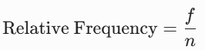
The standard frequency is the raw count (f) of how often a value occurs, and the relative frequency shows the proportion of the total data set that the value represents.

Where:
f = The frequency of an individual score or category
n = The total number of scores or the total sample size (sum f)

- Percentage Distribution
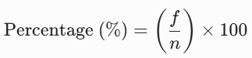
The percentage distribution converts the relative frequency into a percentage, making it easier to compare categories regardless of the total sample size. The formula is shown below:

Where:
P = Percentage
f = Frequency of responses
n = Total number of respondents
- Weighted Mean

A weighted average, also known as a weighted mean, is a computation that takes into account the differing reliability, frequency, or significance of several data points in a study.

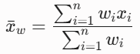
A weighted mean gives some values more "say" according to predetermined criteria, in contrast to a simple average where all numbers have the same weight. The formula is shown below:

Where:
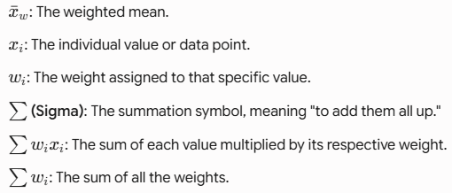

- Likert Scale
The Likert scale is a widely used tool in quantitative research and evaluation for measuring individuals’ attitudes, opinions, or perceptions. It consists of a series of statements or questions to which respondents indicate their level of agreement. Each response is assigned a numerical value, enabling statistical analysis of the results. For this study, a 4-point Likert Scale is employed, with values ranging from 4 (“Strongly Agree”) to 1 (“Strongly Disagree”). The corresponding scale is presented in the table below:
Weighted Point | Scale | Difference | Verbal Interpretation
4 | 3.01-4.00 | 0.99 | Strongly Agree
3 | 2.01-3.00 | 0.99 | Agree
2 | 1.01-2.00 | 0.99 | Disagree
1 | 0.99-1.00 | 0.01 | Strongly Disagree
Table 3: The 4-Point Likert Scale

CRITERIA IN USERS
CRITERIA: | SA (4) | A (3) | DA(2) | SDA(1)
1. Functionality
1.1 The system accurately manages medicine inventory records. | 11 | 27 | 2 | 0
1.2 The system effectively monitors medicine stock levels and expiration dates. | 15 | 24 | 1 | 0
2. Reliability
2.1 The system performs consistently without unexpected errors. | 12 | 26 | 2 | 0
2.2 The system accurately stores and retrieves inventory information. | 13 | 27 | 0 | 0
3. Efficiency
3.1 The system processes inventory transactions quickly. | 10 | 30 | 0 | 0
3.2 The system generates reports within an acceptable response time. | 13 | 26 | 1 | 0
4. Usability
4.1 The system is easy to learn and operate. | 13 | 27 | 0 | 0
4.2 The user interface is simple, organized, and easy to navigate. | 18 | 21 | 1 | 0
- Security
5.1 The system allows access only to authorized users. | 10 | 30 | 0 | 0
5.2 The system protects inventory records from unauthorized access and modification. | 16 | 23 | 1 | 0
(40 RESPONDENTS)
Table 4: The ISO 25010 Evaluation Form

Algorithm Formula: (Users)
no. respondents (4) + no. respondents (3) + no. respondents (2) + no. respondents (1)
---------------------------------------------------------------------------------------------------------- = WM
n
1. Functionality
1.1
44 + 81 + 4 + 0
= 3.2 (WM)
40

(11 * 4) + (27 * 3) + (2 * 2) + (0 * 1)
=
40

Suppose, in a 4-point Likert Scale, 3.2 is interpreted as “Strongly Agree”.

1.2
60 + 72 + 2 + 0
= 3.3 (WM)
40

(15 * 4) + (24 * 3) + (1 * 2) + (0 * 1)
40
=

Suppose, in a 4-point Likert Scale, 3.3 is interpreted as “Strongly Agree”.

Algorithm Formula: (Technical Experts)
no. respondents (4) + no. respondents (3) + no. respondents (2) + no. respondents (1)
---------------------------------------------------------------------------------------------------------- = WM
n
1. Functionality
1.1
12 + 18 + 2 + 0
= 3.2 (WM)
10

(3 * 4) + (6 * 3) + (1 * 2) + (0 * 1)
10
=

Suppose, in a 4-point Likert Scale, 3.2 is interpreted as “Strongly Agree”.

1.2
8 + 21 + 2 + 0
= 3.1 (WM)
10

(2 * 4) + (7 * 3) + (1 * 2) + (0 * 1)
10
=

Suppose, in a 4-point Likert Scale, 3.1 is interpreted as “Strongly Agree”.

1. Functionality | Respondents (50)
1. Functionality | Users (40) |  | Technical (10)
1. Functionality | WM | VI | WM | VI
1.1 The system accurately manages medicine inventory records. | 3.2 | SA | 3.2 | SA
1.2 The system effectively monitors medicine stock levels and expiration dates. | 3.3 | SA | 3.1 | SA
Overall Average Mean | 3.3 | SA | 3.1 | SA
Table 5: Evaluation of Respondents on Functionality
Overall, WM:
Total WM
Total items = Overall WM
Users:
6.5
2

3.2 + 3.3
= 3.3 (Overall WM)
2
=

Technical Experts:

6.3
2

3.2 + 3.1 =
= 3.1 (Overall WM)
2

There are two WMs (3.2 & 3.3) for user respondents. There are two WMs (3.2 & 3.1) for technical respondents.
Functionality is 3.3 interpreted as SA as per the Likert Scale for user respondents and 3.1 as SA in the Likert Scale for technical respondents.
Table 5 evaluates the functionality of the system based on feedback from a total of 50 respondents, divided into 40 users and 10 technical experts. The users rated the system's ability to accurately manage medicine inventory records with a weighted mean of 3.2 and its effectiveness in monitoring stock levels and expiration dates with a weighted mean of 3.3, resulting in an overall user average weighted mean of 3.3, which is verbally interpreted as Strongly Agree. Meanwhile, the technical experts rated the inventory management item at 3.2 and the stock and expiration monitoring item at 3.1, yielding an overall technical average weighted mean of 3.1, which is also interpreted as Strongly Agree. Overall, both groups positively evaluated the core features, showing strong agreement that the system effectively handles medicine records, stock levels, and expiration dates.

Algorithm Formula: (Users)
no. respondents (4) + no. respondents (3) + no. respondents (2) + no. respondents (1)
---------------------------------------------------------------------------------------------------------- = WM
n

2. Reliability

2.1
48 + 78 + 4 + 0
= 3.2 (WM)
40

(12 * 4) + (26 * 3) + (2* 2) + (0 * 1)
=

40

Suppose, in a 4-point Likert Scale, 3.2 is interpreted as “Strongly Agree”.

2.2
52 + 81 + 0 + 0
= 3.3 (WM)
40
(13 * 4) + (27 * 3) + (0 * 2) + (0 * 1)
=

40

Suppose, in a 4-point Likert Scale, 3.3 is interpreted as “Strongly Agree”.

Algorithm Formula: (Technical Experts)
no. respondents (4) + no. respondents (3) + no. respondents (2) + no. respondents (1)
---------------------------------------------------------------------------------------------------------- = WM
n
- Reliability

2.1
8 + 15 + 6 + 0l
= 2.9 (WM)
10

(2 * 4) + (5 * 3) + (3 * 2) + (0 * 1)
=

10

Suppose, in a 4-point Likert Scale, 2.9 is interpreted as “Agree”.

2.2
16 + 15 + 2 + 0
= 3.3 (WM)
10

(4 * 4) + (5 * 3) + (1 * 2) + (0 * 1)
=

10

Suppose, in a 4-point Likert Scale, 3.3 is interpreted as “Strongly Agree”.

2. Reliability | Respondents (50)
2. Reliability | Users (40) |  | Users (10)
2. Reliability | WM | VI | WM | VI
2.1 The system performs consistently without unexpected errors. | 3.2 | SA | 2.9 | A
2.2 The system accurately stores and retrieves inventory information. | 3.3 | SA | 3.3 | SA
Overall Average Mean | 3.3 | SA | 3.1 | SA
Table 6: Evaluation of Respondents on Reliability
Overall, WM:
Total WM
Total items = Overall WM
Users:
6.5
2

3.2 + 3.3
= 3.3 (Overall WM)
=
2
Technical Experts:

6.2
2

2.9 + 3.3
=
= 3.1 (Overall WM)

2
There are two WMs (3.2 & 3.3) for user respondents
There are two WMs (2.9 & 3.3) for technical respondents.
Reliability is 3.3 interpreted as SA as per the Likert Scale for user respondents and 3.1 as SA in the Likert Scale for technical respondents.
Table 6 evaluates the reliability of the system based on feedback from a total of 50 respondents, divided into 40 users and 10 technical experts. The user respondents rated the system's ability to perform consistently without unexpected errors with a weighted mean of 3.2 (Strongly Agree) and its accuracy in storing and retrieving inventory information with a weighted mean of 3.3 (Strongly Agree), resulting in an overall user average weighted mean of 3.3, which translates to Strongly Agree. Meanwhile, the technical expert respondents rated the consistency item at 2.9 (Agree) and the data storage and retrieval item at 3.3 (Strongly Agree), yielding an overall technical average weighted mean of 3.1, which is interpreted as Strongly Agree. Overall, both groups demonstrate positive evaluations of the system's reliability, with users showing strong agreement and technical experts leaning toward agreement to strong agreement regarding consistent performance and information handling.

Algorithm Formula: (Users)
no. respondents (4) + no. respondents (3) + no. respondents (2) + no. respondents (1)
---------------------------------------------------------------------------------------------------------- = WM
n

- Efficiency

3.1
40 + 90 + 0 + 0
= 3.2 (WM)
40

(10 * 4) + (30 * 3) + (0 * 2) + (0 * 1)
=

40

Suppose, in a 4-point Likert Scale, 3.2 is interpreted as “Strongly Agree”.

3.2
52 + 78 + 2 + 0
= 3.3 (WM)
40

(13 * 4) + (26 * 3) + (1 * 2) + (0 * 1)
=

40

Suppose, in a 4-point Likert Scale, 3.3 is interpreted as “Strongly Agree”.

Algorithm Formula: (Technical Experts)
no. respondents (4) + no. respondents (3) + no. respondents (2) + no. respondents (1)
---------------------------------------------------------------------------------------------------------- = WM
n
3. Efficiency

3.1
16 + 12 + 4 + 0
= 3.2 (WM)
10

(4 * 4) + (4 * 3) + (2 * 2) + (0 * 1)
=

10

Suppose, in a 4-point Likert Scale, 3.2 is interpreted as “Strongly Agree”.

3.2
16 + 15 + 2 + 0
= 3.3 (WM)
10

(4 * 4) + (5 * 3) + (1 * 2) + (0 * 1)
=

10

Suppose, in a 4-point Likert Scale, 3.3 is interpreted as “Strongly Agree

3. Efficiency | Respondents (50)
3. Efficiency | Users (40) |  |  | Users (10)
3. Efficiency | WM | VI | WM | VI
3.1 The system processes inventory transactions quickly. | 3.2 | SA | 3.2 | SA
3.2 The system generates reports within an acceptable response time. | 3.3 | SA | 3.3 | SA
Overall Average Mean | 3.3 | SA | 3.2 | SA

Table 7: Evaluation of Respondents on Efficiency
Overall, WM:
Total WM
Total items = Overall WM
Users:
3.2 + 3.3
= 3.2 (Overall WM)
6.5
2

2
=

Technical Experts:
3.2 + 3.3
= 3.2 (Overall WM)
6.5
2

=
2

There are two WMs (3.2 & 3.3) for user respondents
There are two WMs (3.2 & 3.3) for technical respondents.
Efficiency is 3.3 interpreted as SA as per the Likert Scale for user respondents and 3.2 as SA in the Likert Scale for technical respondents.
Table 7 evaluates the efficiency of the system based on feedback from a total of 50 respondents, consisting of 40 users and 10 technical experts. The user respondents rated the system's speed in processing inventory transactions with a weighted mean of 3.2 and its ability to generate reports within an acceptable response time with a weighted mean of 3.3, resulting in an overall user average weighted mean of 3.2, which is interpreted as Strongly Agree. Similarly, the technical expert respondents rated both the transaction processing speed and report generation response time with weighted means of 3.2 and 3.3 respectively, yielding an overall technical average weighted mean of 3.2, which is also verbally interpreted as Strongly Agree. Overall, both groups demonstrate strong positive evaluations, indicating that the system operates efficiently in handling transactions and generating timely reports.

Algorithm Formula: (Users)
no. respondents (4) + no. respondents (3) + no. respondents (2) + no. respondents (1)
---------------------------------------------------------------------------------------------------------- = WM
n
- Usability

4.1
52 + 81 + 0 + 0
= 3.3 (WM)
40
(13 * 4) + (27 * 3) + (0 * 2) + (0 * 1)
=

40

Suppose, in a 4-point Likert Scale, 3.3 is interpreted as “Strongly Agree”.

4.2
72 + 63 + 2 + 0
= 3.4 (WM)
40

(18* 4) + (21 * 3) + (1* 2) + (0 * 1)
=

40
Suppose, in a 4-point Likert Scale, 3.4 is interpreted as “Strongly Agree”.

Algorithm Formula: (Technical Users)
no. respondents (4) + no. respondents (3) + no. respondents (2) + no. respondents (1)
---------------------------------------------------------------------------------------------------------- = WM
n

4. Usability

4.1
12 + 15 + 4 + 0
= 3.1 (WM)
10

(3 * 4) + (5 * 3) + (2 * 2) + (0 * 1)
=

10

Suppose, in a 4-point Likert Scale, 3.1 is interpreted as “Strongly Agree”

4.2
16 + 15 + 2 + 0
= 3.3 (WM)
10

(4 * 4) + (5 * 3) + (1 * 2) + (0 * 1)
=

10

Suppose, in a 4-point Likert Scale, 3.3 is interpreted as “Strongly Agree”

4. Usability | Respondents (50)
4. Usability | Users (40) |  | Users (10)
4. Usability | WM | VI | WM | VI
4.1 The system is easy to learn and operate. | 3.3 | SA | 3.1 | SA
4.2 The user interface is simple, organized, and easy to navigate. | 3.4 | SA | 3.3 | SA
Overall Average Mean | 3.4 | SA | 3.2 | SA

Table 8: Evaluation of Respondents on Usability
Overall, WM:
Total WM
Total items = Overall WM
Users:
3.3 + 3.4
= 3.3 (Overall WM)

6.7
2

=
2

Technical Experts:
3.1 + 3.3
= 3.2 (Overall WM)
6.4
2

=
2
There are two WMs (3.3 & 3.4) for user respondents
There are two WMs (3.1 & 3.3) for technical respondents.
Usability is 3.4 interpreted as SA as per the Likert Scale for user respondents and 3.2 as SA in the Likert Scale for technical respondents.
Table 8 evaluates the usability of the system based on feedback from a total of 50 respondents, consisting of 40 users and 10 technical experts. The user respondents rated the system's ease of learning and operation with a weighted mean of 3.3 and the simplicity, organization, and navigation of the user interface with a weighted mean of 3.4, yielding an overall user average weighted mean of 3.3, which translates to Strongly Agree. Similarly, the technical expert respondents rated the system's ease of learning and operation at 3.1 and the user interface characteristics at 3.3, resulting in an overall technical average weighted mean of 3.2, which is also verbally interpreted as Strongly Agree. Overall, both groups display strong positive evaluations regarding the system's usability, indicating that the interface is clean, well-organized, and user-friendly.

Algorithm Formula: (Users)
no. respondents (4) + no. respondents (3) + no. respondents (2) + no. respondents (1)
---------------------------------------------------------------------------------------------------------- = WM
n
- Security

5.1
40 + 90 + 0 + 0
= 3.2 (WM)
40
(10 * 4) + (30 * 3) + (0 * 2) + (0 * 1)
=

40

Suppose, in a 4-point Likert Scale, 3.2 is interpreted as “Strongly Agree”.

5.2
64 + 69 + 2 + 0
= 3.3 (WM)
40

10
(16* 4) + (23 * 3) + (1* 2) + (0 * 1)
=

40

Suppose, in a 4-point Likert Scale, 3.3 is interpreted as “Strongly Agree”.

Algorithm Formula: (Technical Experts)
no. respondents (4) + no. respondents (3) + no. respondents (2) + no. respondents (1)
---------------------------------------------------------------------------------------------------------- = WM
n
5. Security

5.1
12 + 18 + 2 + 0
= 3.2 (WM)
10

(3 * 4) + (6 * 3) + (1 * 2) + (0 * 1)
=

10

Suppose, in a 4-point Likert Scale, 3.2 is interpreted as “Strongly Agree”.

5.2
12 + 12 + 6 + 0
= 3.0 (WM)
10

(3 * 4) + (4 * 3) + (3 * 2) + (0 * 1)
=

10

Suppose, in a 4-point Likert Scale, 3.0 is interpreted as “Agree”.
- Security | Respondents (50)
- Security | Users (40) |  | Users (10)
- Security | WM | VI | WM | VI
5.1 The system allows access only to authorized users. | 3.2 | SA | 3.2 | SA
5.2 The system protects inventory records from unauthorized access and modification. | 3.3 | SA | 3.0 | A
Overall Average Mean | 3.3 | SA | 3.1 | SA

Table 9: Evaluation of Respondents on Security

Overall, WM:
Total WM
Total items = Overall WM
Users:
3.2 + 3.3
= 3.2 (Overall WM)
6.5
2

=
2

Technical Experts:
3.2 + 3.0
= 3.1 (Overall WM)
6.2
2

=
2

There are two WMs (3.2 & 3.3) for user respondents
There are two WMs (3.2 & 3.0) for technical respondents.
Security is 3.3 interpreted as SA as per the Likert Scale for user respondents and 3.1 as SA in the Likert Scale for technical respondents.
Table 9 evaluates the security of the system based on feedback from a total of 50 respondents, consisting of 40 users and 10 technical experts. The user respondents rated the system's restriction of access solely to authorized users with a weighted mean of 3.2 and its protection of inventory records from unauthorized access and modification with a weighted mean of 3.3, resulting in an overall user average weighted mean of 3.2, which translates to a verbal interpretation of Strongly Agree. Meanwhile, the technical expert respondents rated the authorized access feature with a weighted mean of 3.2 and the protection against unauthorized access and modification with a weighted mean of 3.0 (Agree), yielding an overall technical average weighted mean of 3.1, which is verbally interpreted as Strongly Agree. Overall, both groups demonstrate positive evaluations regarding system security, showing that the evaluators generally agree or strongly agree that the system adequately safeguards inventory information and controls user access.
Criteria  (ISO25010) | Respondents (50)
Criteria  (ISO25010) | Users (40) |  | Technical (10)
Criteria  (ISO25010) | WM | VI | WM | VI
- Functionality | 3.3 | SA | 3.1 | SA
- Reliability | 3.3 | SA | 3.1 | SA
- Efficiency | 3.3 | SA | 3.2 | SA
- Usability | 3.4 | SA | 3.2 | SA
- Security | 3.3 | SA | 3.1 | SA
Overall Average Mean | 3.4 | SA | 3.1 | SA
Table 10: Summary & Comparison of Evaluations of Respondents
Table 10 summarizes and compares the evaluations of 50 respondents, consisting of 40 users and 10 technical experts, across the five ISO 25010 criteria. For the user respondents, functionality, reliability, and security each received a weighted mean of 3.3, efficiency received a weighted mean of 3.3, and usability received a weighted mean of 3.4, culminating in an overall average mean of 3.4 with a verbal interpretation of Strongly Agree. Meanwhile, the technical experts rated functionality, reliability, and security each with a weighted mean of 3.1, while efficiency and usability each received a weighted mean of 3.2, resulting in an overall average mean of 3.1 with a verbal interpretation of Strongly Agree. Overall, both groups consistently rated all criteria with strongly agree verbal interpretations, indicating an exceptionally positive evaluation of the system's overall quality and performance across all measured dimensions.

